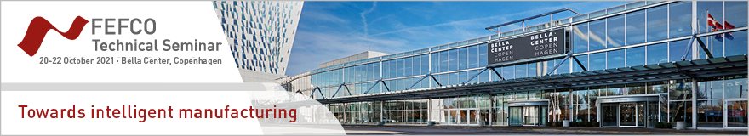

PRESS REGISTRATION FORM

Please complete and e-mail this form to Houriet Lefebvre at houriet.lefebvre@fefco.org.

We will register you at no cost and send you a confirmation. You will receive a badge onsite on the first day of the event that gives you full access to the three-day FEFCO Technical Seminar.

Newspaper/Magazine/Organisation ……………………………………………………………………………………

Title  Mr.  Mrs  Ms
First name ……………………………………… Last name ………………………………………….
Function ………………………………………………………………………………………………………........
Address ………………………………………………………………………………………………………........
Postal Code …………… City ………………………… Country ………………………………………… Phone ……………………………………… Email* ……………………………………………………

* All communication regarding the Technical Seminar will be by email.

I would like to display magazines and / or newsletters  Yes  No

Date Signature

